**­­­**

Class 7

**Lecture 16**

**HTML**

**HTML List**

**HTML**



**Lab Objectives:**

* HTML List.
* HTML .Order List
* HTML Unordered List

**HTML List**

HTML offers web authors three ways for specifying lists of information.

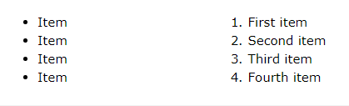

All lists must contain one or more list elements. Lists may contain −

* **<ul>** − An unordered list. This will list items using plain bullets.
* **<ol>** − An ordered list. This will use different schemes of numbers to list your items.
* **<dl>** − A definition list. This arranges your items in the same way as they are arranged in a dictionary.

**HTML Unordered Lists**

An unordered list is a collection of related items that have no special order or sequence. This list is created by using HTML <ul> tag. Each item in the list is marked with a bullet.

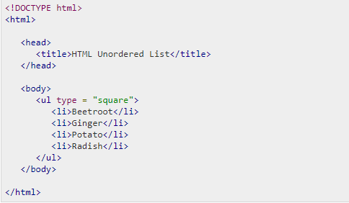.

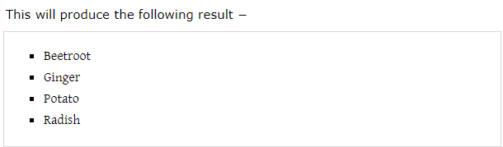

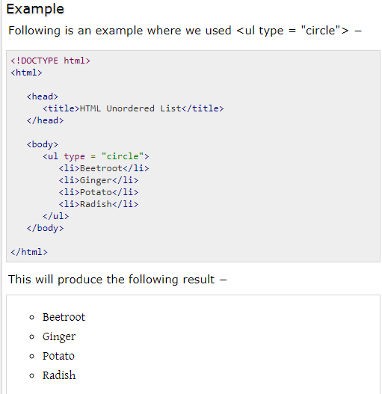

**HTML Ordered Lists**

If you are required to put your items in a numbered list instead of bulleted, then HTML ordered list will be used. This list is created by using <ol> tag. The numbering starts at one and is incremented by one for each successive ordered list element tagged with <li>.

